RESEARCH STUDY - FEBRUARY 2026
AI FOR AMERICANS FIRST
AI Protectionism, Energy and Semiconductors: US/Europe Divergence Trajectories 2024-2030
Integrated Geostrategy and Economic Analysis - CHAPTER VII
76.9% of global operational AI compute = USA | 1.59x EU/US energy cost (PPP-adjusted) | 3.46:1 US/EU CACI ratio (Power Mode)

Fabrice Pizzi
Universite Paris-Sorbonne
Master 2 Intelligence Economique - Intelligence Warfare
Paris - February 2026 | 7 Chapters | 4 Prospective Scenarios | 3 Geographic Zones
Keywords: artificial intelligence, technological protectionism, semiconductors, export controls, sovereign compute, AI geopolitics, France, United States, China
CHAPTER VII
Strategic Recommendations for France and Europe
The previous chapters have established that American AI protectionism creates a measurable structural competitive advantage (US/EU CACI Power Mode of 3.46:1 on the April 2026 snapshot, operational installed compute raw ratio of 17.6:1), accelerated by the 2026 Trump tariffs and the concentration of compute in the United States (76.9% of global operational AI compute, 660-690 billion USD in annual capex from hyperscalers alone). This chapter formulates strategic recommendations articulated across three time horizons and five structuring axes, leveraging France's specific comparative advantages (nuclear, Mistral, regulation) and existing European instruments (AI Continent Action Plan, Chips Act, InvestAI).
7.1 Axis 1 - Compute infrastructure: closing the gap
7.1.1 Short term (2026-2027): accelerating AI Factories
The starting point is the infrastructure gap. The EU has approximately 35 GW of IT data center capacity compared to 53.7 GW in the United States and 19.6 GW in China. In strict AI compute, the April 2026 public dashboard establishes an EU(13) F_total share of 3.3% versus 76.9% for the United States, representing a raw operational ratio of 17.6:1 and a CACI Power Mode ratio (geometric formula F^0.40 x L^0.20 x R^0.15 / E^0.25) of 3.46:1. Three immediate measures are required.
First, accelerate the commissioning of the 13 European AI Factories already created across 17 Member States (AI Continent Action Plan, April 2025), with a target of full operationality by the end of 2027 instead of the 2028-2029 horizon currently envisioned.[1] Second, implement the Special Compute Zones proposed by the Centre for Future Generations, which are derogatory zones (accelerated permits, reduced taxation, priority network connection) for AI data centers of national importance.[2] France has already initiated this process with legislation envisioned to designate data centers as projects of major national interest. Third, secure long-term GPU contracts with Nvidia, AMD, and Intel via multilateral framework agreements (EU-Nvidia, EU-AMD) guaranteeing a minimum annual delivery volume.
A key nuance from the Phys/Sov analysis of Chapter I (Fig 1.8): on physically installed compute, the EU is already largely sovereign (99.2% of EU F_total is held by EU operators). The window of vulnerability is therefore not so much on installed F as on the cloud workload layer (the compute actually used by EU companies, mostly hosted on AWS/Azure/GCP). The following recommendations primarily target this operational layer.
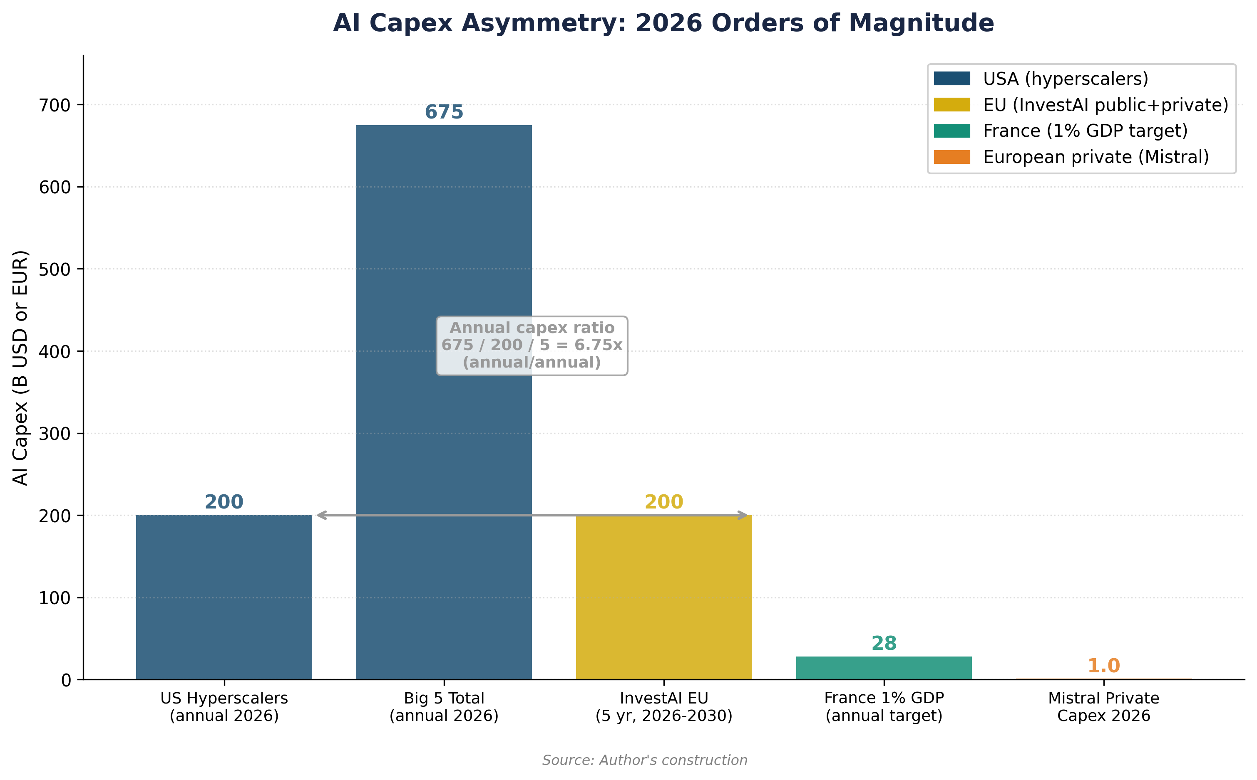

7.1.2 Medium term (2027-2029): AI Gigafactories and sovereign cloud
The InvestAI program provides for 200 billion EUR (50 billion public, 150 billion private), including 20 billion for five AI Gigafactories that will allow for the creation of sovereign frontier models.[3] This program must be calibrated against the American benchmark: the 660-690 billion USD in 2026 capex from the five US hyperscalers alone represents more than three times the European envelope over five years. The investment gap is structural and will not be closed by public funds alone.[4]
France has a distinctive advantage in this competition. The MGX-Bpifrance-Mistral-Nvidia AI campus, announced at the Choose France Summit 2025, plans for 1.4 GW of compute power powered by nuclear energy, with exascale capabilities operational by 2028.[5] Mistral Compute, launched with 18,000 Nvidia Grace Blackwell superchips in a 40 MW data center in Essonne, constitutes the first credible European offer of frontier compute without exposure to the CLOUD Act. Mistral's capex of 1 billion EUR for 2026, supplemented by the Borlänge data center (Sweden, 1.2 billion EUR, green energy, opening 2027), shows that a European champion can build an alternative infrastructure.[6]
Sovereign cloud constitutes the necessary complement. The ANSSI's SecNumCloud 3.2 certification and the S3NS joint venture (Thales-Google Cloud, SecNumCloud certified December 2025), the Bleu joint venture (Orange-Capgemini-Microsoft, milestone 1 reached November 2025), and the AWS European Sovereign Cloud (launched January 2026, separate German GmbH) create a gradually sovereign ecosystem.[7] The goal should be to reach 30-40% of sensitive AI workloads hosted on certified sovereign cloud by 2029. It is precisely the increase in the F_sov factor (Chap V section 5.9.2) that protects against the hypothetical activation of US Cloud Sovereignty Mandates in 2028.
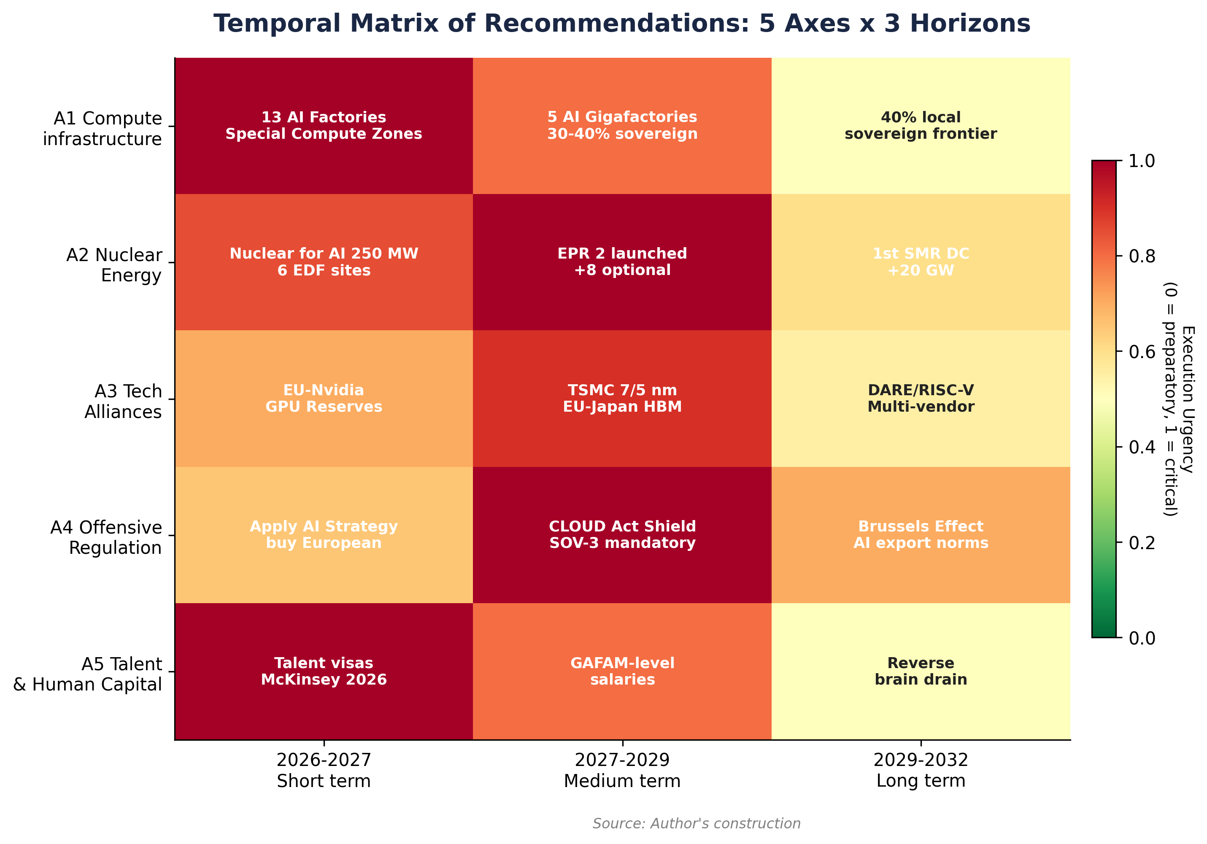

7.2 Axis 2 - Energy: transforming the nuclear asset into a compute advantage
7.2.1 The French energy advantage
France has a unique energy advantage in Europe: 70% low-carbon nuclear electricity, a fleet of 56 reactors (plus Flamanville 3 at full power), competitive electricity costs, and a robust transport infrastructure. On the April 2026 snapshot of the public dashboard, the France/USA PPP-adjusted cost stands at 115 versus 85 USD/MWh, a 1.35x ratio much more favorable than the EU average (135 USD/MWh, 1.59x ratio). EDF has identified four industrial sites totaling 2 GW (expandable to six sites by 2026), with direct connection to the grid, reducing connection delays.[8] EDF's Nuclear for AI initiative plans for 250 MW connected to AI chips by the end of 2026, creating a new off-take market for nuclear power.
This advantage is explicitly recognized by international investors. Investments announced at the February 2025 AI Action Summit total 109 billion EUR, including Brookfield/Data4 (20 billion), UAE (30-50 billion), and Fluidstack (10 billion for a 1 GW supercomputer powered by nuclear, operational 2026).[9] France is the only European country capable of simultaneously offering abundant low-carbon electricity, baseload grid stability, and tariff competitiveness for AI data centers—a triptych that neither Germany (nuclear exit), nor the Netherlands (grid constraints), nor Ireland (energy saturation) can reproduce.
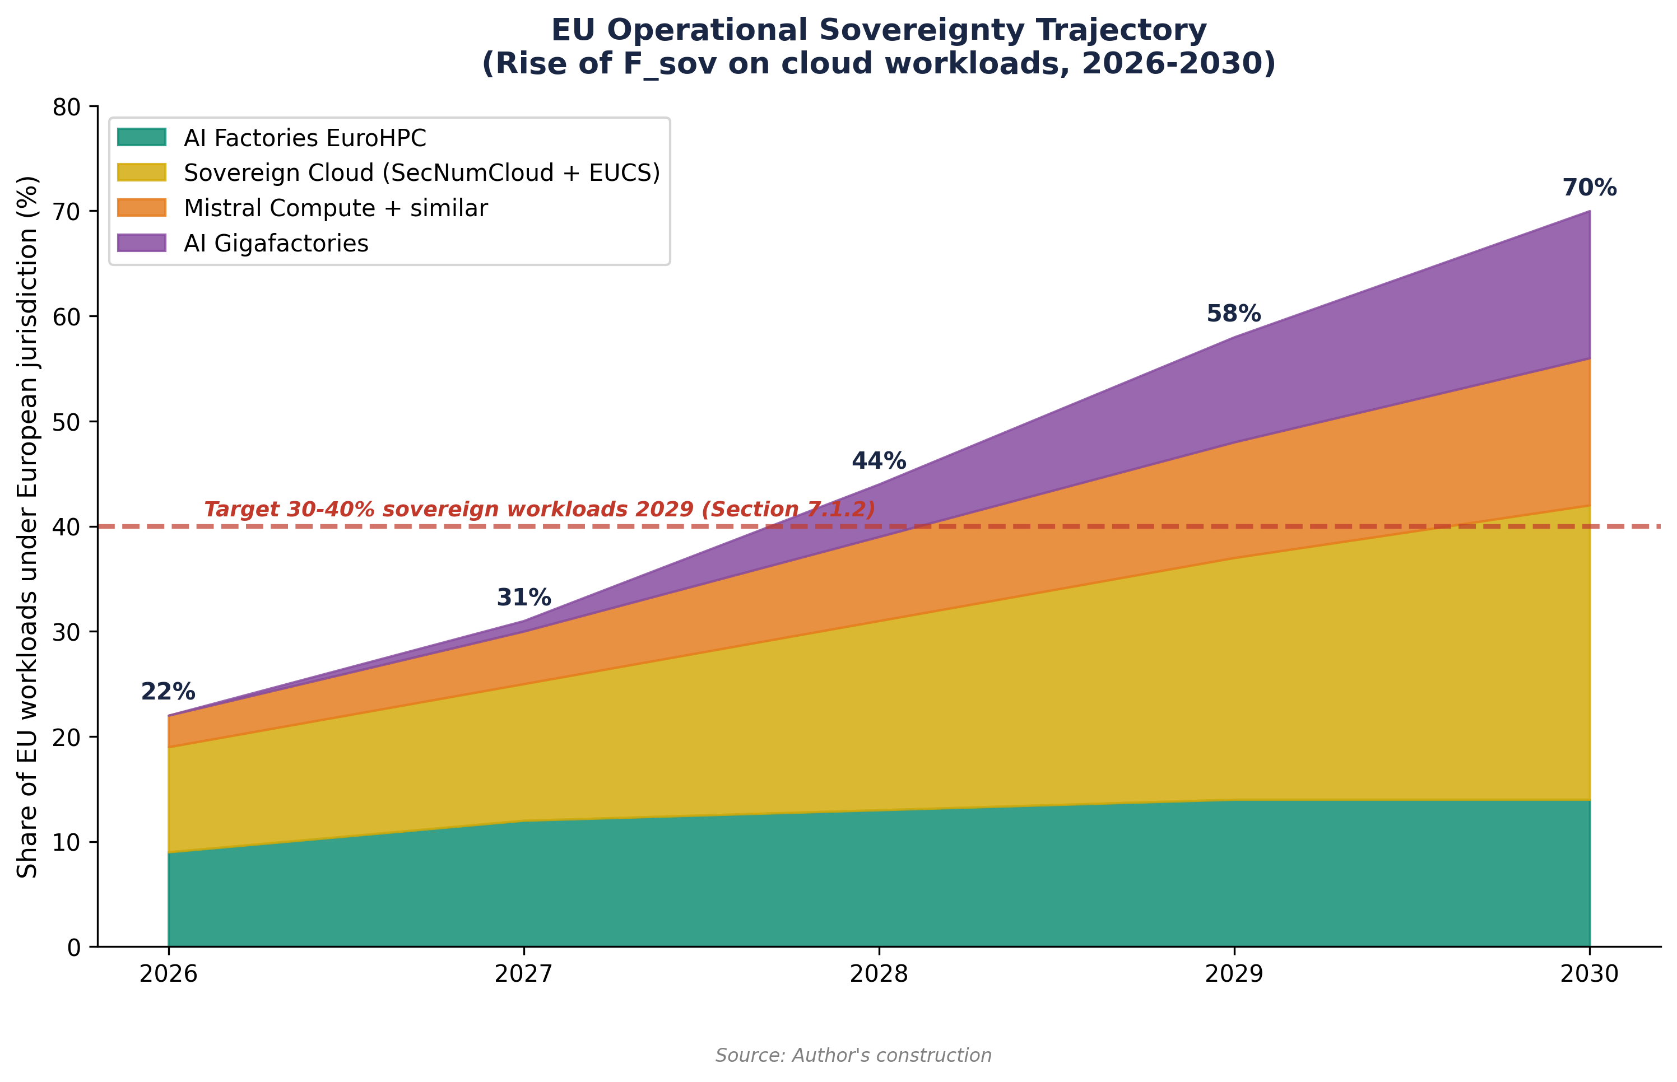

7.2.2 Energy recommendations
First, accelerate the EPR 2 program. The six announced EPR 2 reactors (Penly, Bugey, 9,900 MW, construction from 2027) must be explicitly integrated into data center energy planning. The addition of eight additional optional reactors should be confirmed before 2028, to anticipate 2032-2035 demand.[10]
Second, support SMRs (Small Modular Reactors). The France 2030 program allocates 1 billion EUR to SMRs. NUWARD (EDF subsidiary, 340 MWe) remains the most advanced project. Three startups (Newcleo, Stellaria, Jimmy Energy) filed applications with the ASN in late 2025-early 2026. The goal should be the first commercial SMR dedicated to a data center by 2033-2035, with a pilot connected to an AI campus. However, uncertainty over SMR commercialization timelines dictates that it should not be the sole strategy.[11]
Third, plan AI-grid energy integration. RTE projects an additional 10 GW need for data centers by 2030 in France. Integrating AI demand forecasts into national grid planning (in line with the McKinsey recommendation to align AI growth with sustainable energy expansion) is indispensable to avoid bottlenecks.[12]
7.3 Axis 3 - Technological alliances and supply chain diversification
7.3.1 Consolidating asymmetric industrial partnerships
The analysis of Chapters VI, VI bis, VI ter, and VI quater reveals that France and Europe do not intend to reproduce the entire AI value chain (which is unrealistic by 2030), but must build targeted strategic alliances that reduce the most critical dependencies.
ASML-Mistral Alliance. ASML's 1.3 billion EUR investment in Mistral AI (September 2025, ASML becoming the primary shareholder at 11%) is the most significant European partnership, linking the global leader in lithography (a critical segment where Europe dominates) to the European AI champion.[13] This type of vertical coupling of European hardware plus European AI should be systematized.
TSMC-Europe Partnership. The TSMC Dresden plant (10 billion EUR, production started 2027) manufactures chips on 28/16/12 nm nodes—insufficient for frontier AI GPUs but critical for automotive and industrial IoT. Negotiating a second TSMC investment in Europe on more advanced nodes (7/5 nm) should be a diplomatic priority.
Japan-EU and Korea-EU Alliances. Japan and Korea control critical segments of the value chain that the United States cannot substitute (SK hynix HBM memory, Tokyo Electron and Shin-Etsu equipment and materials). Bilateral EU-Japan and EU-Korea agreements on the security of AI component supply, structured outside the US-Japan-Korea trilateral framework, would strengthen European autonomy. Chapter VI ter documented that Japanese investment in the United States (550 billion USD) is unilateral—a cross EU-Japan investment would balance this dynamic.
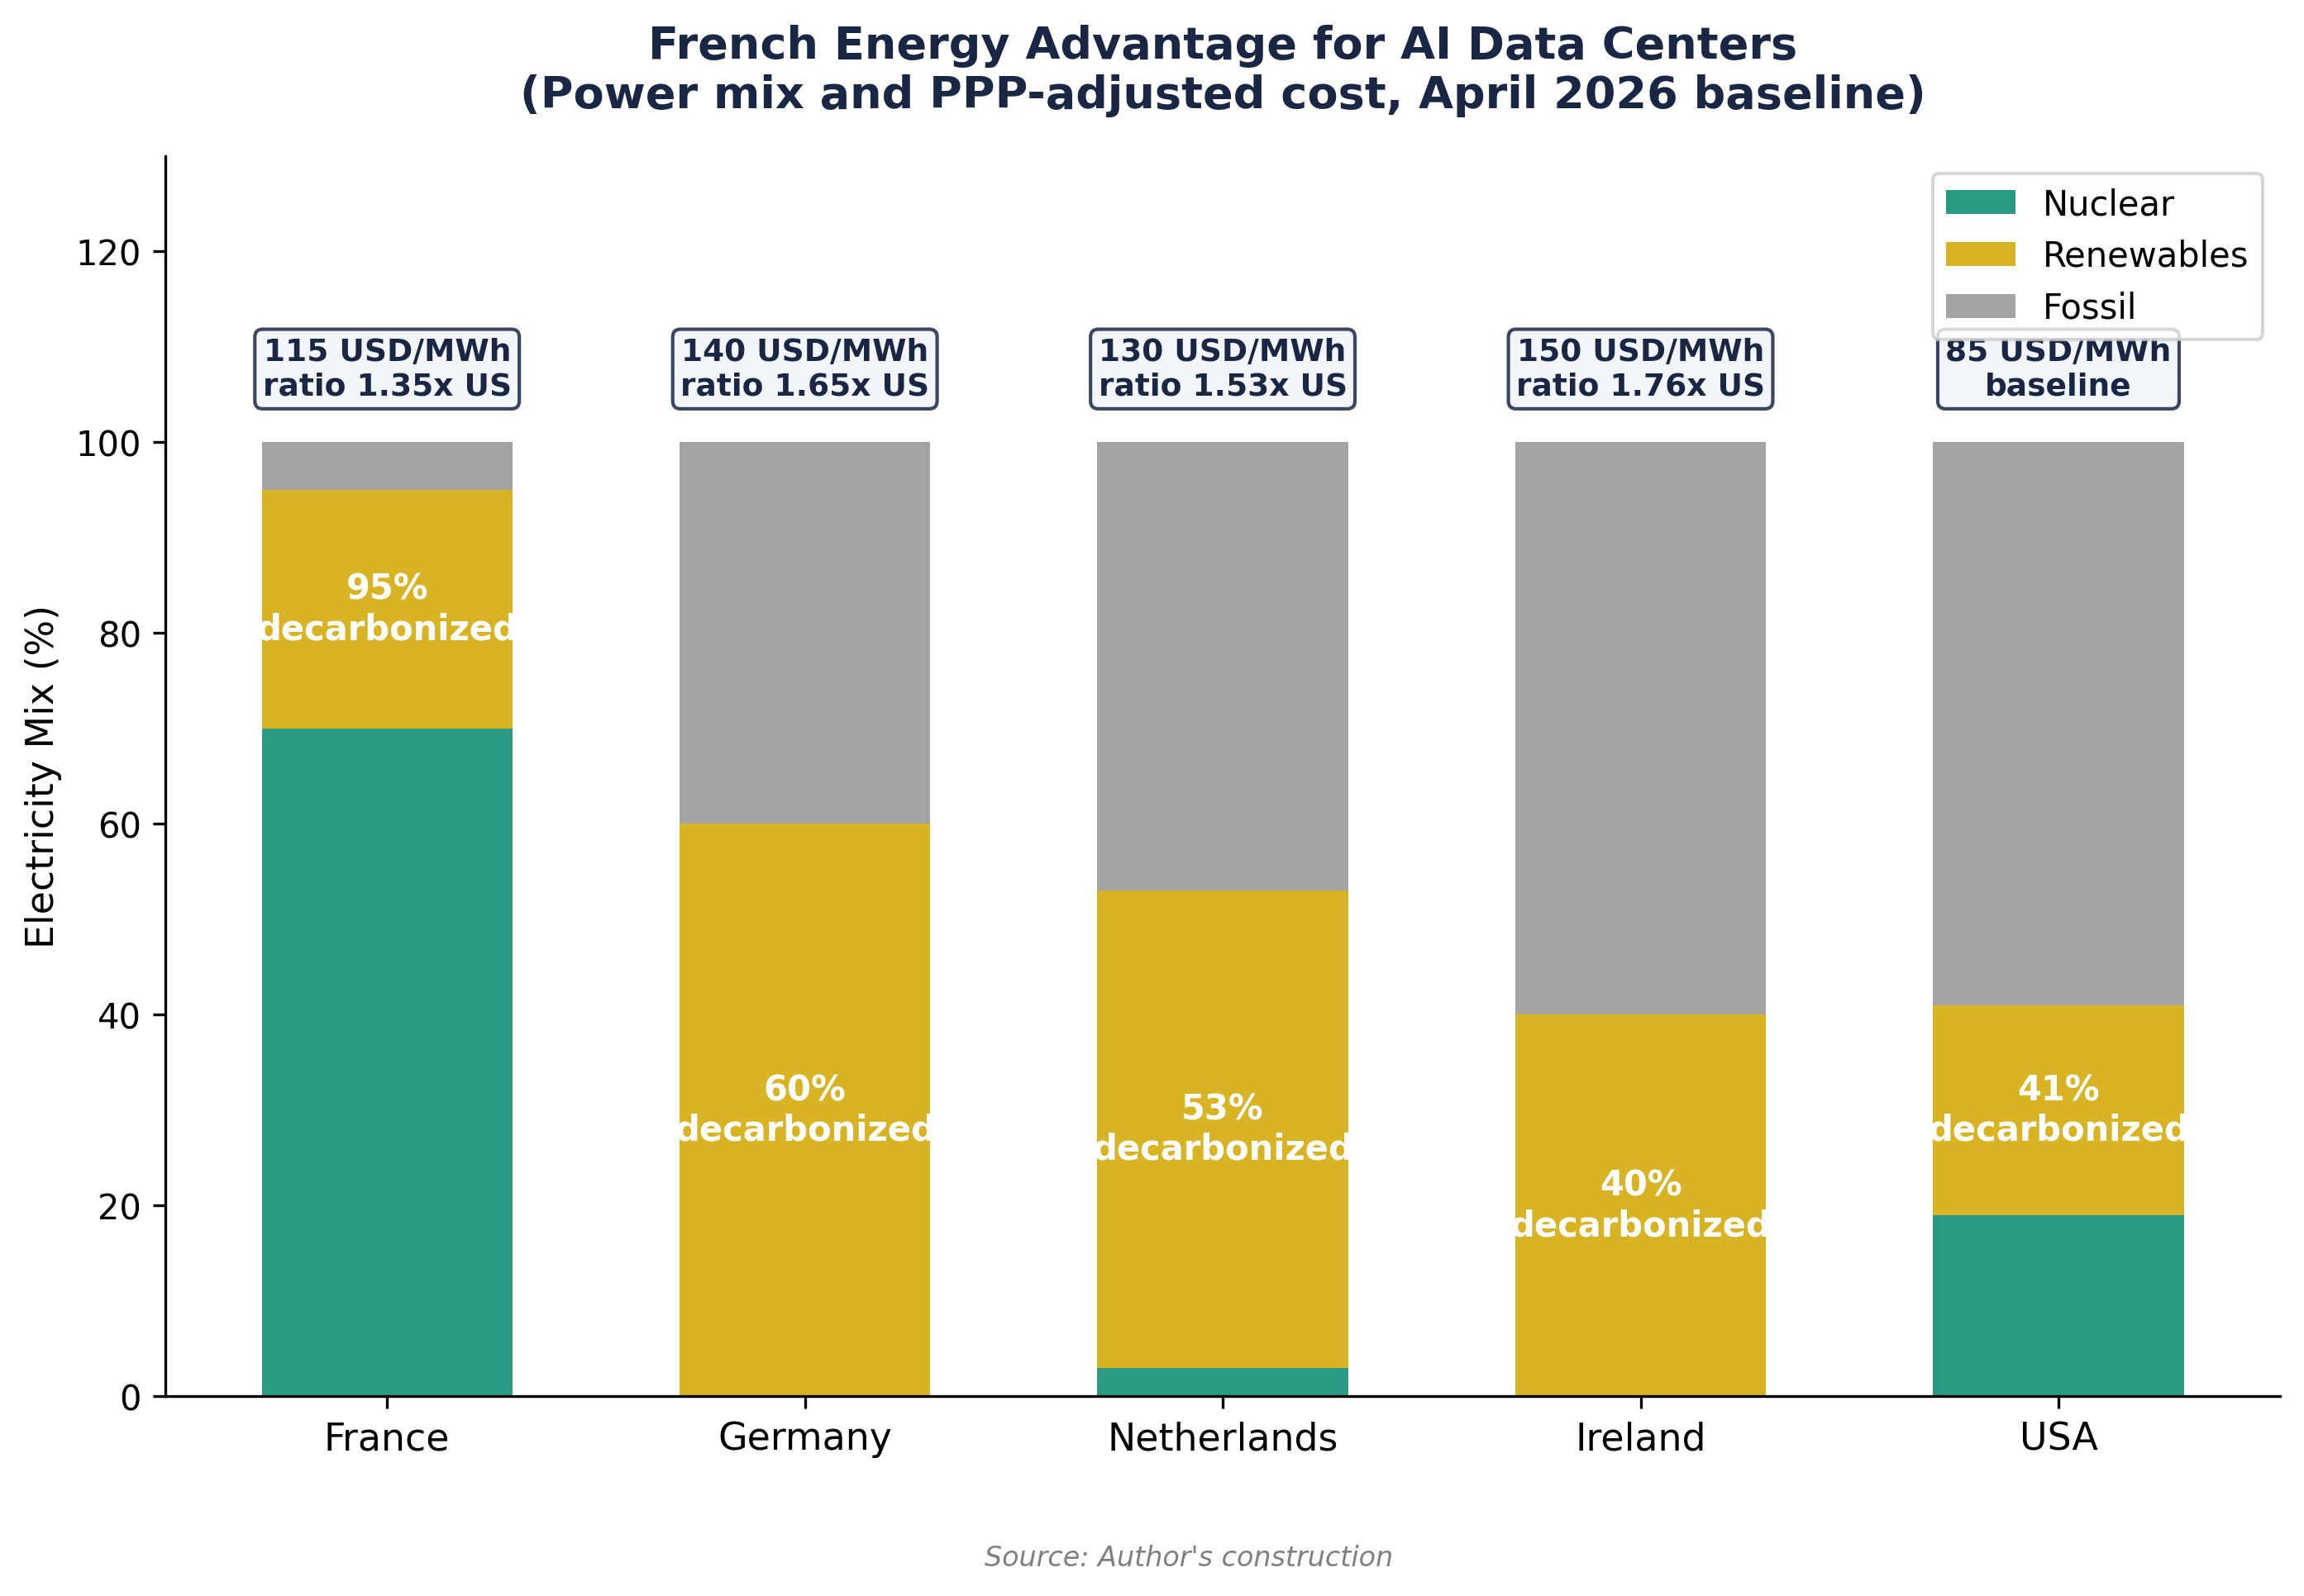

7.3.2 Reducing exposure to protectionist risk
The Biden-Trump experience shows that export controls and tariffs can be extended rapidly and unpredictably. Three risk reduction measures are required.
Constitution of strategic GPU reserves. On the model of strategic oil reserves (90 days), constitute a national/European stock of AI accelerators covering 6 to 12 months of projected needs. This stock would serve as a buffer against any activation of the Affiliates Rule (suspended until November 2026) or extended Section 232 tariffs.
Hardware provider diversification. Accelerate the evaluation and deployment of alternatives to Nvidia GPUs: AMD MI300X/MI350X, Intel Gaudi 3, Graphcore (UK), and eventually SiPearl (European, Rhea processor for supercomputers). Finance via the European Chips Act a multi-vendor AI accelerator qualification program. The DARE project (European RISC-V, EuroHPC JU) is the 2030-2032 horizon, but intermediate alternatives are available immediately.
Anti-weaponization clauses in trade agreements. Integrate into the future EU-US trade agreement clauses preventing the unilateral use of export controls as a commercial competitiveness instrument, on the model of WTO non-discrimination clauses.
7.4 Axis 4 - Regulation as a competitive advantage
7.4.1 From the AI Act to the Apply AI Strategy
Mistral CEO Arthur Mensch summarized the European paradox: you cannot regulate your way to compute supremacy.[14] The AI Act, in progressive application since 2024, imposes obligations (transparency, risk assessments, compliance) that constitute both a burden for European companies and a differentiation advantage in global markets. The Apply AI Strategy (2025) complements the AI Act by adopting an AI-first approach for the public sector and promoting buy European, particularly for open-source solutions.[15]
The recommendation is to transform regulation into an offensive rather than defensive lever. Three concrete measures can contribute to this.
(a) Require that AI Factories and AI Gigafactories funded by InvestAI prioritize the use of European models (Mistral, Aleph Alpha, etc.) and certified clouds (SecNumCloud, high-level EUCS).
(b) Exploit the Brussels Effect: global companies complying with the AI Act to access the European market (450 million consumers) de facto adopt European standards, creating a normative advantage. Accelerate mutual recognition agreements with Japan, Brazil, and India.
(c) Create a European CLOUD Act Shield: blocking legislation (on the model of the 1996 EU blocking regulation) preventing European companies from complying with extraterritorial US access requests without authorization from the competent national authority. This measure is the legal instrument that gives substance to the SOV-3 Cloud Sovereignty Framework published by the Commission in October 2025 (Chap V section 5.10.4).
7.4.2 Regulation of compute as a strategic asset
Comparative analysis (Chapters V and VI ter) shows that frontier compute is now treated by the United States, China, Japan, India, and the Gulf States as a national strategic asset on par with energy or critical raw materials. Europe must formalize this recognition. Gartner predicts that countries pursuing independent AI stacks will need to invest at least 1% of GDP in infrastructure by 2029.[16] For France, this would represent approximately 28 billion EUR annually, an order of magnitude consistent with the 109 billion in investments announced in 2025 (of which a significant portion comes from foreign capital).
The UAE case documented in Chapter I (Fig 1.8) constitutes a warning: 99.6% of Emirati F_total is held by US-side operators, dropping the sovereign CACI from 55.7 to 6.0. An investment attraction policy indifferent to the legal nationality of operators would reproduce this pattern in Europe. European compute regulation must provide for minimum domestic ownership thresholds (for example, 50% minimum of operators under EU jurisdiction for sites over 100 MW), with a mechanism analogous to the Investment Screening Mechanism already applied to strategic investments.
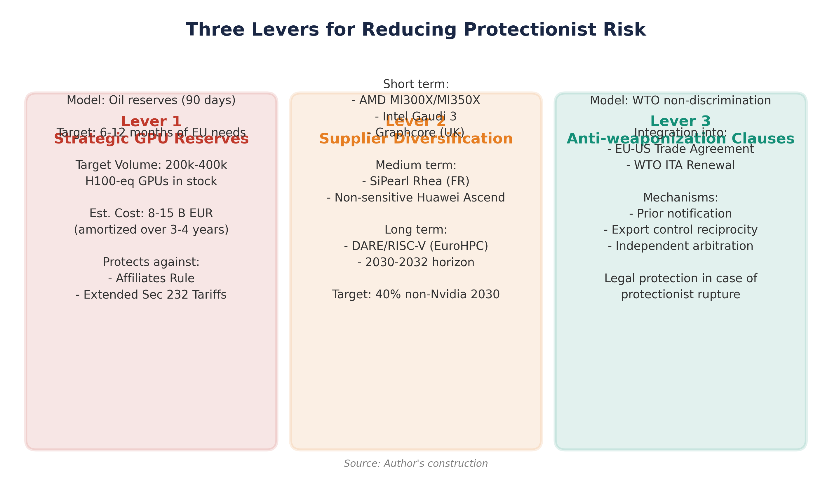

7.5 Axis 5 - Talent and human capital
Infrastructure without talent produces nothing. Europe is losing AI researchers to American laboratories (salaries, access to frontier compute, scale of projects). Two complementary measures are required.
First, European AI fellowships and talent visas (McKinsey recommendation: launch before end 2026) to attract world-class researchers.[17] France has an advantage with the Mistral/LightOn/Hugging Face ecosystem and the grandes écoles (Polytechnique, ENS, CentraleSupélec), but must match the salaries offered by GAFAM (average x2 to x4 gap for senior AI profiles).
Second, guarantee European researchers access to compute equivalent to that of American laboratories. The deployment of 500,000 GPUs via Fluidstack (operational 2026), the 18,000 Mistral Compute superchips, and the EuroHPC AI Factories constitute the beginning of a response. The goal is that no European researcher leaves the continent for compute access reasons by 2028.
7.6 Synthesis: temporal matrix of recommendations
Table 23 below summarizes the recommendations by crossing three horizons (2026-2027, 2027-2029, 2029-2032) with the Compute, Energy, and Alliances axes. The Regulation and Talent axes are deployed transversally across the three horizons and are not detailed line by line in the matrix.
7.7 Success conditions and limits
Several conditions will determine the effectiveness of these recommendations.
Condition 1: Mistral's competitiveness. The entire French AI sovereignty strategy relies in part on Mistral's ability to maintain competitive performance against OpenAI, Anthropic, and Google DeepMind. If the capability gap widens, French infrastructure will serve compliance needs (sovereign hosting of US models) rather than true technological sovereignty.[18] The 1.7 billion EUR fundraising (11.7 billion valuation) and the establishment of Mistral Compute are positive signals, but the scale of competition (OpenAI: 20 billion USD in 2025 recurring revenue) remains disproportionate.
Condition 2: industrial execution. European AI infrastructure programs have historically suffered from delays (EuroHPC, Chips Act). The 13 AI Factories must be operational, not just announced. The experience of Japan (Rapidus 2 nm program) and India (gap between 200+ billion announcements and 1.4 GW installed capacity) illustrate the risks of misalignment between ambition and realization.
Condition 3: European coherence. Intra-European fragmentation (27 energy regimes, divergent positions on nuclear, competing national sovereignty approaches) remains the main obstacle. Scenario C of Chapter V (asymmetric partnership, baseline 3.46:1 toward 2.0-2.5:1) only works for Europe if it speaks with one voice in negotiations with Washington.
Condition 4: the time factor. The tipping point identified in Chapter V (2028, EU compute plus energy saturation, and potential activation of Cloud Sovereignty Mandates) imposes a constrained schedule. If the AI Factories are not operational and the EDF sites not connected by that date, the compute gap will solidify into structural dependence. The window for strategic action is between 2026 and 2028—after which positions crystallize around the 17.6:1 raw / 3.46:1 CACI Power Mode baseline.
Table 23. Temporal matrix of strategic recommendations by axis (2026-2032).
Source: Author's construction; April 2026 baseline (US/EU operational raw compute 17.6:1, CACI Power Mode 3.46:1).
Horizon | Compute Axis | Energy Axis | Alliances Axis
2026-2027 | 13 AI Factories operational; FR Special Compute Zones; long-term GPU contracts | 250 MW nuclear-AI (EDF); 6 EDF data center sites; Fluidstack 1 GW operational | EU-Nvidia volume agreement; strategic GPU reserves; AI talent visas
2027-2029 | 5 AI Gigafactories (20B EUR); 30-40% sovereign workloads; 1.4 GW MGX-Mistral Campus | 6 EPR 2 construction started; AI integration in grid plan; 8 optional EPRs confirmed | TSMC Europe 7/5 nm node; EU-Japan/Korea HBM agreements; European CLOUD Act Shield
2029-2032 | 40% local compute (vs 5%); sovereign frontier models; SiPearl EU AI accelerator | First SMR data center; +20 GW nuclear 2035; integrated AI energy mix | Multi-vendor GPU qualified; AI export norms (Brussels effect); 60% value chain autonomy

Notes
1. European Commission (April 2025), AI Continent Action Plan. 13 AI Factories in 17 Member States, 200B EUR InvestAI program. Apply AI Strategy (2025): AI-first approach, buy European.
2. Centre for Future Generations (October 2025), 'Special Compute Zones: Europe's Recipe'. Derogatory zones to reduce data center installation times from 3-5 years to 12-18 months.
3. Deloitte (November 2025), 'A New Era of Self-Reliance'. InvestAI: 20B EUR for 5 AI Gigafactories, sovereign frontier models.
4. Euronews (February 2026), 'Will Big Tech's AI Spending Crush Europe's Data Sovereignty?' 2026 capex: Amazon 200B USD, Alphabet 185B USD, Microsoft 145B USD, Meta 135B USD, Oracle 50B USD. Total: 660-690B USD. European sovereign cloud spending: 10.6B EUR 2026.
5. Global Data Center Hub (May 2025), 'France's 8.5 Bn USD AI Campus'. MGX-Bpifrance-Mistral-Nvidia AI Campus: 1.4 GW, exascale, operational 2028.
6. Euronews, op. cit. Mistral Compute: 18,000 Grace Blackwell, 40 MW Essonne. Capex 1B EUR (2026). Borlänge data center (Sweden): 1.2B EUR, EcoDataCenter, green energy, opening 2027.
7. Julien Simon, Medium (January 2026), 'AI Sovereignty in Europe: A Decision Framework'. S3NS: SecNumCloud December 2025. Bleu: milestone 1 November 2025. AWS European Sovereign Cloud: January 2026, Brandenburg GmbH.
8. World Nuclear News (February 2025), 'France Tempts AI Firms with Nuclear Electricity'. EDF: 4 sites, 2 GW total, call for expression of interest. Data4: 40 MW nuclear supplied by EDF. France PPP-adjusted cost 115 USD/MWh according to public dashboard (April 2026).
9. Introl Blog (2025), 'France's AI Sovereignty Push'. AI Action Summit: 109B EUR. Bpifrance: 10B EUR. Fluidstack: 10B EUR, 500,000 GPUs, 1 GW, operational 2026.
10. Enki AI (February 2026), 'Top 10 Nuclear & SMR Projects in France'. EPR 2: 6 reactors (Penly, Bugey), 9,900 MWe, construction 2027. Option for 8 additional reactors. 20 existing reactors: life extension (26 GW).
11. Enki AI, op. cit. NUWARD: 340 MWe, EDF/Naval Group subsidiary. France 2030: 1B EUR SMR. Newcleo, Stellaria, Jimmy Energy: ASN applications filed. Counter-point: Beyond Nuclear International (January 2026) signals financial difficulties for some SMR startups.
12. McKinsey (December 2025), 'Accelerating Europe's AI Adoption: The Role of Sovereign AI'. Recommendation: integrate AI demand forecasts into national energy planning. Productivity gains: up to 40% in lighthouse factories.
13. S&P Global (December 2025), 'Geopolitics of Data Centers'. ASML: 1.3B EUR in Mistral (September 2025), 11% stake. Mistral fundraising: 1.7B EUR, 11.7B EUR valuation.
14. Euronews, op. cit. Arthur Mensch (2025) quote: 'US companies are building the equivalent of a new Apollo program every year' and 'you cannot regulate your way to computing supremacy'.
15. European Commission (2025), Apply AI Strategy. AI-first for the public sector, buy European for open-source solutions. AI Observatory for trend monitoring.
16. Intelligent CIO Europe (February 2026). Gartner: 1/3 of companies will use localized AI platforms by 2027 (vs 5% today). Minimum 1% of GDP investment in AI infrastructure by 2029.
17. McKinsey, op. cit. AI fellowships and talent visas to be launched before end 2026. 44% of European tech leaders cite data security as a barrier to public cloud; 31% data localization.
18. Introl Blog, op. cit. 'If the capability gap widens, French infrastructure may serve compliance requirements without enabling competitive AI applications.' OpenAI: 20B USD ARR 2025 (x3 in one year).

License and Disclaimer. This work, 'AI for Americans First', is made available under the terms of the Creative Commons Attribution-NonCommercial-ShareAlike 4.0 International (CC BY-NC-SA 4.0) license. You are free to share and adapt the material for non-commercial purposes, provided you properly attribute the work to Fabrice Pizzi (Université Paris-Sorbonne) and distribute your contributions under the same license. This document is provided for educational and research purposes only.
Public Dashboard : https://mo0ogly.github.io/America-First-IA/dashboard/
Repository : https://github.com/mo0ogly/America-First-IA
AI for Americans First - Fabrice Pizzi - Chapter VII

